Community Connectors round 2: Helping small and mid-sized communities repair the damage of divisive infrastructure
With support from the Robert Wood Johnson Foundation, Smart Growth America is continuing the Community Connectors program to help advance locally driven projects to reconnect communities separated or harmed by transportation infrastructure. In this round, the program will be narrowly focused on communities with divisive or dangerous arterial roads or streets in need of changes to improve safety or reconnect divided neighborhoods.

This call for applications will support three teams from small to mid-sized cities (between approximately 50,000 and 500,000 in population) to participate in a yearlong cohort (September 2025 - June 2026) for training and support, culminating in the design and implementation of a temporary street safety pilot project to test out permanent changes to reconnect the community.

These joint teams must consist of local government and a community-based organization of some kind, and will receive in-depth instruction in building safer, complete streets through virtual training, a $25,000 grant to implement a street safety demonstration project, as much as $20,000 in in-kind support from outside engineering experts to support project design, and travel budget for a (mandatory) two-day convening in one of the three cities in fall 2025 for a site visit, walk audit, training, and project design.

Applications open on July 23, 2025, and are due by August 31, 2025, at 11:59 p.m. Full eligibility details and requirements are outlined below.

Repairing the damage of divisive infrastructure
Smart Growth America’s ongoing Community Connectors program seeks to equip small and mid-sized communities to identify, remove, or repair the damage of divisive infrastructure. Because Congress has moved to essentially kill the popular Reconnecting Communities program by rescinding and taking back more than $2.4 billion for these projects—much of that already awarded to local communities—one of the best available sources of dedicated funding for these types of projects has disappeared overnight.

But that does not mean these types of projects cannot move forward. Although costly projects to remove or cap an entire highway or repair the damage of an enormous legacy interstate project will be far more difficult without this program, there are countless ways to use existing federal, state, or local money to quickly make unsafe and divisive roadways safer and more accessible. And implementing a quick-build demonstration project on roads like these can be an important first step toward a more ambitious permanent project. This iteration of the Community Connectors program is narrowly focused on divisive arterial highways and other dangerous roads that have divided or damaged communities.

The objectives of this program are to:

- Make dangerous streets and roads safer; start repairing damage and division. Learn how demonstration projects are a proven strategy to make dangerous streets safer today, while also making the case for permanent changes tomorrow.
- Develop new skills that can be used on future projects. Create the kind of experience and capacity that can be used on other projects in the future, so that the community can design and implement other safety pilot projects on their own.
- Learn more about Complete Streets. Learn together and from one another about the role that a Complete Streets approach plays in addressing traffic violence and building great places.
- Build trust and lasting partnerships. Help these teams build the trust required to tackle more of these sorts of projects, repair past damage, and address what is often a legacy of harm. Bring teams together that include community-based organizations and local governments, but also potentially transit agencies, health advocates, housing non-profits, land trusts, major employers, lenders & others.
- Share lessons with others. Produce a report with case studies, lessons learned and recommendations to support this work more broadly both in experimental quick-builds and more permanent Complete Streets support.

The Complete Streets Leadership Academy
This iteration of the Community Connectors program will be utilizing a proven training curriculum called the Complete Streets Leadership Academy (CSLA). This model combines a series of virtual sessions and in-person workshops to develop and deploy community-led quick-build projects on a road or street. Program participants are city or county staff, engineers, or planners; in partnership with community-based organizations and advocates who represent the neighborhoods and places most damaged and affected. (In this case, teams are required to be joint partnerships between a city or local unit of government and a community-based organization of some kind.)

The ~30-40 hours of sessions and workshops will cover the basics of quick-build projects including site selection, design, community engagement, and data collection. The teams will engage in peer-to-peer learning and work to identify and overcome barriers in policies and practices to implement a Complete Streets approach that can repair the damage of a divisive road.

Over the course of the workshop series each participating local team will also collectively plan and implement a “quick-build” demonstration project, using proven safety countermeasures, tactical urbanism, and creative placemaking to temporarily transform a street or intersection into a safer route that is also less divisive. SGA will work with each community to help them refine the specific location for their project, but communities do need to have a tentative corridor or intersection(s) identified in their application for a demonstration project.

Requirements for participating communities
- Community size: Teams representing cities between ~50,000 and ~500,000 in population.
- Joint applications and team composition: All applications must be a joint endeavor between a local government unit and a community-based organization or similar organization that represents the affected residents or neighborhood(s). Teams consisting only of local government will not be considered.
- Other team notes: Teams are not required but are strongly encouraged to meet regularly (bi-weekly, etc) outside of the required CSLA training meetings to build trust, strengthen partnerships, and create the foundation required for a successful project. (SGA staff will be available to attend some of these additional meetings, but we have found that regular and ongoing communication amongst the team is vital for project success.)
- Demonstration project requirement: Selected communities must commit to designing and installing a temporary street safety demonstration project for a minimum of one month.
- Infrastructure type and identification: While final site decisions will be made during the cohort, the team must identify their preferred corridor or intersection(s) in their application, which must be owned and controlled by one of the participating government units (in order to implement the temporary demonstration project). State-owned roadways are not eligible for this program unless the city manages or operates them independently.
- Eligible entities: Government agencies (including US territories), tribes, non-profit community-based nonprofit organizations, and academic institutions are eligible. Each team must identify a public and community-based org as co-leads on the application.
- In-person convening: Teams are required to be able to participate in an in-person training in Oct-Nov, 2025 in one of the three selected cities. We will also be looking for a host city, which can be noted on the application. Travel and hotel costs will be covered for a subset of each team (~5-6 people) traveling to the location. (All members of the host team would be expected to participate.)
- Eligible funding uses: Up to $25,000 will be given to each community for the demonstration project and their time. A portion of this money (at least $5,000) is reserved to compensate the CBO co-lead for their time.
- Ineligible funding uses: According to Robert Wood Johnson Foundation policy, funds may not be used “to support clinical trials of unapproved drugs or devices, to construct or renovate facilities, for (permanent) capital costs of any kind, for lobbying-related activities and expenses, for political activities, or as a substitute for funds currently being used to support similar activities.”
- Assent to participate in evaluation: An independent research group selected and funded by RWJF will conduct an evaluation of this program. As a condition of accepting this assistance, grantees agree to participate in the evaluation, which will be concurrent with the program.
- Reporting requirements: Members of the cohort will be expected to provide narrative and financial reports on request. Teams will be required to participate in periodic meetings and provide interviews and quotes for an SGA case study at the end of the project.
- Photos and media. SGA will be leaning on the teams to document their projects through photos and potentially video, which can be provided on request for use in SGA case studies and other promotional materials.

Selection criteria
- Geographic diversity: Smart Growth America will attempt to select projects that span the country and a range of population sizes within the stated eligibility.
- Need, with a priority on lower-capacity communities: Priority will be given to teams/projects that place a clear emphasis on bringing measurable benefits to communities that are low-income and/or low-capacity, with a history of disinvestment and damage from past infrastructure decisions—particularly communities of color.
- A connection to urban renewal or past history of harm and division: Our ideal project is one with a connection to urban renewal, 1960s road-building, or other intentional efforts to divide and harm communities that were predominantly low-income or communities of color. (See the case study below for an example.)
- Readiness and commitment: Cities need to be fully committed to designing and implementing a temporary project on a dangerous road or street that they own and control.
- Teaming arrangement and partnerships: Ideal teams will include public agencies and community-based organizations and advocates (and other stakeholders) to scope and advance these projects, while building partnerships for the future.

Timeline
- September: program kick-off with introductory calls
- October: virtual trainings to introduce Complete Streets and quick builds and to build connections within the cohort
- November: in-person training at one of the three selected cities, to conduct a walk audit and begin initial design, and virtual trainings on engagement, data collection, and communications planning
- December: teams conduct community engagement and outreach to finalize project design
- January-February: virtual presentations from each team on their final design, virtual trainings on project launch and maintaining momentum after a quick build, and teams procure materials for demonstration projects
- March-May: quick-build demonstration projects installed and evaluated
- May: final project presentations from each team at virtual session

Read this story of an ideal project type - Harrisonburg, VA

Harrisonburg, Virginia was selected for a previous round of the Community Connectors program where 15 communities received capacity building subgrants and wraparound technical assistance to develop and advance ambitious projects to restore the damage of past infrastructure decisions. One of Harrisonburg’s final projects (a temporary demonstration project) helped inspire this year’s specific focus on divisive or dangerous roadways.
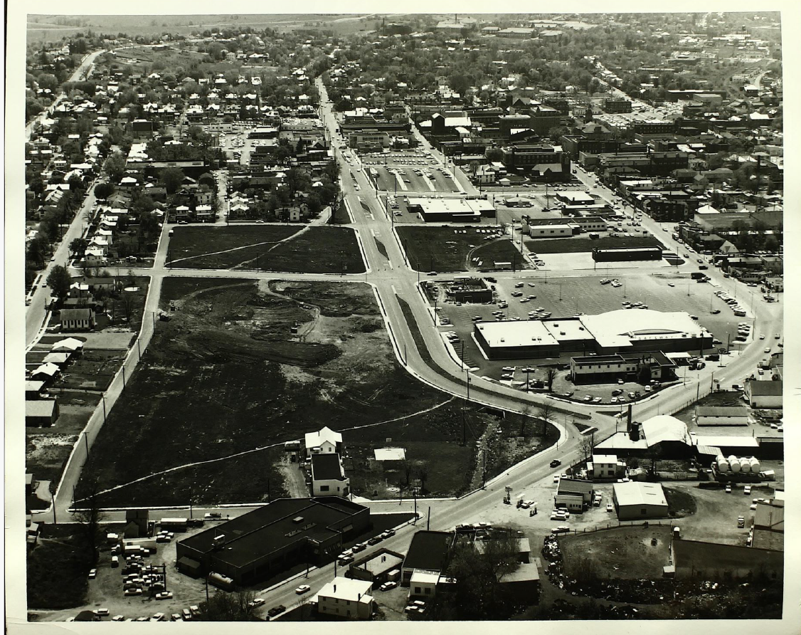
The city-led Harrisonburg team came in with a project proposal to reimagine or rework Mason Street, a four-lane arterial just north of downtown originally built during the larger project of “urban renewal” in the 1960s in the historically Black Northeast Neighborhood. As part of those “renewal” activities, black-owned businesses were seized, more than a hundred homes were taken and families displaced, and the city’s housing authority was created to implement these damaging plans. Many properties were seized to add a new street within this small city’s street grid, but instead of a modest city street, it was built to the typical 1960s standards of the time with five wide lanes and a clear focus on moving vehicles quickly right through the middle of the heart of the city. The result is a physical and emotional scar that to this day that separates the historic fabric of downtown and the Northeast neighborhood.

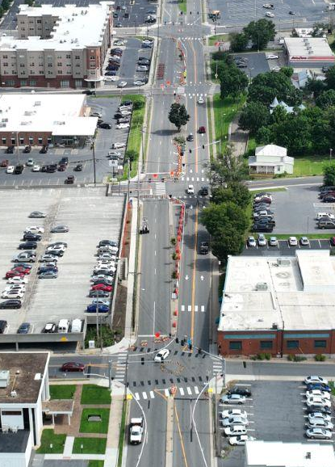
The city’s team included two Black-led community-based organizations in the neighborhood. Building trust between the neighborhood writ large and the city was a core priority for this team. So when it became clear early on that the neighborhood hadn’t been fully engaged in the city’s original aspirations to remake Mason Street, the city took a step back to prioritize the needs and desires of the neighborhood first and use the program to advance a small-area planning process for the entire NE neighborhood. 12-18 months into the two-year program, SGA staff suggested that a logical step toward reimagining Mason Street could be our Complete Streets Leadership Academy and a temporary project to test designs, gather feedback, and further engage the NE neighborhood. The team invited additional residents and city staff to participate in a CSLA cohort, which culminated with the team designing and implementing a month-long temporary demonstration project on Mason Street to test out their ideas and engage the broader community with them as well.

Mason Street is four lanes divided by a median with occasional turn lanes. The final temporary project design closed the southbound side of the median and converted the northbound side into two-way travel, eliminated three traffic lights in favor of two-way stops and two new temporary roundabouts, and created new crosswalks, among other improvements. Data collection is still ongoing throughout July but initial observations showed no major impact on traffic, with travel times that appeared shorter for travel along the entire four-block corridor.

Here are some key contributors to the success of their project—which also point to what we want to emulate with the teams in this next round of the Community Connectors program.

- The team included numerous city departments (Public Works, Planning and Community Development, the City Manager’s office, Communications) but also demonstrated a real commitment to participation by having the deputy city manager serve as the project lead, with the full backing of the city manager.
- The core team included an elected city council member who also runs a black history nonprofit based in the NE neighborhood, and a NE neighborhood association leader.
- The core team met weekly for the duration of the Community Connectors program (and CSLA), alternating between in-person and virtual meetings.
- We often say that “projects move at the speed of trust,” and when it became clear that trust levels were low and the overall initial project idea developed by the city didn’t have community buy-in, the city paused, took a step back, altered the course of their project to develop a project together that everyone supported.
- The core Community Connectors team was expanded for the Complete Streets Leadership Academy. The team brought in several NE neighborhood residents, more city staff, a member of the local bike advocacy coalition, and a pastor and resident in NE. The DPW director also participated in every session, which was crucial as the head of the department responsible for implementing the final demonstration project. And the team allowed a portion of their grant to be used to compensate the residents and CBO members for their time.
- Mason Street wasn’t just a dangerous street in need of changes. It was also intrinsically connected to the city’s painful history of using transportation to intentionally segregate, divide, and displace people. We are hopeful to find other streets with a similar history for this round of projects.
- The city controls all of the streets within their borders, even the two main state routes. This made changes easy to coordinate within just one level of government.

APPLICATION
HOW TO APPLY ONLINE
Apply online at https://www.smartgrowthamerica.org/services/community-connectors-2/ where you can find an interactive application and all supplemental information and documents. We highly recommend downloading this application as a .doc file, preparing your answers in advance in the doc, pasting them into the online application, and submitting them all at once. Click “File >> Download >> Microsoft Word (.docx) There are maximum character counts for each question, but there are no penalties for writing shorter answers.

Questions? Please submit through the online form at https://www.smartgrowthamerica.org/contact-us/

Applications are due by August 31, 2025 at 11:59 p.m. Eastern time. Please don’t wait until the last minute to prepare and submit your application.

Local commitments
If awarded this technical assistance, do you commit to completing a Complete Streets demonstration project within the duration of the Academy, and keeping it in place for a minimum of one month?
- I commit to performing this action
- I cannot commit to this action
If awarded this technical assistance, do you commit to engaging a cohort of approximately 8-10 local decision-makers, staff, and stakeholders that will participate in each one of a series of virtual workshops (approximately 30 hours total)? The in-person workshop is also part of this training, but will likely involve a smaller subset of this cohort (5-6) for the two city teams that are traveling.
- I commit to performing this action
- I cannot commit to this action
If awarded this technical assistance, would you be able to host an in-person workshop in your jurisdiction?
- We can host a meeting
- We can host a meeting and potentially provide food or other materials

Project description
Describe the road or street creating the damage or disconnection: Describe your proposed corridor or intersection(s). Where is it located? (X street between Y and Z streets. The X000 block of MLK Ave) While we will be refining the final project site selections during the cohort training, you will need a specific corridor or intersection in mind. Max 100 words.

Explain the division or danger. Tell us about the division and danger created by this road or corridor. How does it divide communities? Feel free to share about the history. When was it built or widened? How were those decisions made? What sort of barriers does it create? What data do you have on serious injuries or deaths along it? Max 100 words.

Community information and teaming arrangement

Community overview: Describe your city or community and the affected project area (if known), including data on demographic information (population, race, income, etc), community type (urban, suburban, exurban, rural), land use (residential, commercial, industrial, mixed use, etc), important destinations (job center, schools, etc). What is important for us to know about your city? 500 words maximum.

Community co–empowerment and engagement.
Describe the strategy and scope of any community engagement thus far on your project idea. Who has been involved in developing and identifying this corridor/project idea? How have the affected residents and neighborhoods been engaged and involved in the process?

Co-lead local government organization
- Jurisdiction name:
- Lead contact name:
- Title
- Email
- Phone
- Partnership: Describe your relationship with the CBO or other community organization listed below:

Co-lead community-based government organization.
- Organization name:
- Lead contact name:
- Title
- Email
- Phone
- Partnership: Describe your relationship with the city or government agency listed above:

Team list
Please list at least 5-6 (and no more than 12 individuals) with names, titles, and departments or organizations who you expect to include in your cohort. This is not intended to be an ironclad final list of the team which will likely be larger, but more like a starting point for your ideal team. I.e, you are likely to discover during the onboarding process a vital person or organization that is not presently at the table. SGA will help you fill out the full team during the onboarding process, so this list does not have to be final.

Outcomes

Has your community ever completed a demonstration project or tactical urbanism project before?

- Yes
- No

If so, please describe:

What are you hoping to achieve from the Community Connectors program? Why are you most interested in applying?

What has your jurisdiction already done to implement Complete Streets or repair the damage of past street design decisions?

What do you see as the biggest barriers and challenges to participating in this program and completing a demonstration project?

Other information Any helpful links you’d like to include (letters of support from an elected official, department head, other community groups; existing project website, photos of site, etc.), please include here. If applicable, add text here, 100 word maximum:

